The WRIISC program is asking VISN directors and registry coordinators to
assist with getting this revised template activated within their local CPRS
systems. This WRIISC template will need to be imported onto local CPRS
systems throughout the national VAMC system.

To get the template to work properly a Clinical Coordinator authorized to edit shared templates must perform the following steps from the CPRS GUI.

Follow steps A, and then B or C or both B and C, depending on where the current WRIISC template is located on your system at this time.

A.RETRIEVING CPRS TEMPLATES from a Webpage:
1. Access the webpage where the template is located
2. Find the template to retrieve
3. Right-click template and click “SAVE TARGET AS”
4. Change “SAVE IN” to “DESKTOP”
6. Click SAVE
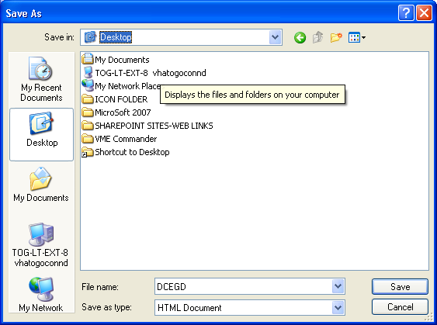

B. To replace the current WRIISC template with the revised WRIISC template (Not in document titles):
- Go to the Notes tab.
- From the Options menu, select Edit Shared Templates
- Find the current WRIISC template
- Highlight the current WRIISC template
- Right-click on the current WRIISC template
- Click Delete Template
- Inactivate template by clicking the Ignore button
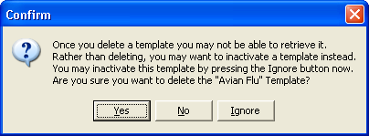
- Highlight Shared template folder
- From the Tools menu, select Import Template
10.Look in: “DESKTOP”
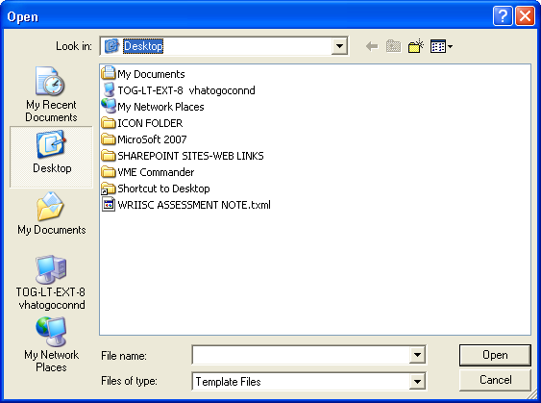
10.Select WRIISCASSESSMENT.TXML and press Open

C. To replace the current WRIISC template with the revised WRIISC template that is associated with note title WRIISC ASSESSMENT NOTE:

- Go to the Notes tab.
- In the Shared Templates pane highlight Document Titles.
- Find the current WRIISC ASSESSMENT NOTE Title
- Highlight the current WRIISC ASSESSMENT NOTE title
- Right-click on the current WRIISC ASSESSMENT NOTE title
- Click Delete template
- Press Apply
- Highlight Document Titles
- From the Tools menu select Import Template.
10.Look in: “Desktop”
11.Select WRIISCASSESSMENT.TXML and press Open.
12.In the Associated Title list box, select WRIISC ASSESSMENT NOTE.
13.Press Apply
14.Press OK.

Once these steps have been performed, the template and note title will work for all CPRS users. Further information about setting up shared templates is available in the Computerized Patient Record System (CPRS) User Guide in the section on Creating Personal Document Templates.

